Free Good Load process with Deb

Updated 27 Mar 17

Fig 1.

|  |  |  |
| --- | --- | --- |
| **ID** | **Field** | **Data** |
| 1 | RecID | 23728 |
| 2 | Div | AAD |
| 3 | Setleader | {TC how is this pulled?} |
| 4 | Buy | Buy 7 Boxes of Safetouch Advanced Form Nitrile PF Gloves |
| 5 | Get | Get 3 Boxes free |
| 6 | VendorName | AR Medicom |
| 7 | VendorID | MEDICO |
| 8 | SetLeader_Name | Safetouch Advanced Form Nitrile PF Gloves |
| 9 | Redeem | {External Redeem} Goods Shipped with Order |
| 10 | Quarter | {Private Note} Q1 2017 Part 1 |
|  |  |  |
| 12 | Note | {Internal Redeem, SAME as #9} Goods Shipped with Order |
| 13 | DateRecChg |  |
| 14 | DateRecUpdate | 19-Dec-16 |
| 17 | AutoAdd | TRUE |
| 21 | EffDate | 01-Jan-17 |
| 22 | RedeemDate | 31-Mar-17 |
| 23 | Expired | 31-Mar-17 |
| 24 | AsysNote | From: January-01-2017 To March-31-2017  _Buy 7 Boxes of Safetouch Advanced Form  _Nitrile PF Gloves Get 3 Boxes free  _Goods Shipped with Order **Auto Added** _ |
| 25 | ExportFlag | 0 |

Fig 2

| **Buy List** | | |
| --- | --- | --- |
| **RecID** | **ItemNumber** | **ItemDescription** |
| 23728 | 5844304 | SafeTouchAdv Form Glove XS |
| 23728 | 5848742 | SafeTouchAdv Form Glove M |
| 23728 | 5842676 | SafeTouchAdv Form Glove S |
| 23728 | 5843409 | SafeTouchAdv Form Glove XL |
| 23728 | 5846294 | SafeTouchAdv Form Glove L |

Fig 3

|  |  |  |
| --- | --- | --- |
| **Detail Type** | **Item Select** | **Family Set Select** |
| Buy X, Get X | 80% |  |
| Buy X, Get Y |  |  |

Fig 4

|  |  |  |  |  |  |  |
| --- | --- | --- | --- | --- | --- | --- |
|  |  |  | **"Glove senario"** | **"Tooth paste / floss senario"** | **"3M Discs get Discs"** | **"3M Discs get Strips** |
| **ID** | **Field** | **Sample** | **Case 1: buy X get X (@ item level; 3 Red pen + 1 Free Red)** | **Case 2: buy X get Y (@ item level; 3 Red pen + 1 FreePencil)** | **Case 3: buy X get X (@ Family set level; 1 Red + 1 Blue + 1 Black = 1 Free Blue)** | **Case 3: buy X get Y (@ Family set level; 1 Red + 1 Blue + 1 Black = Default or CSR choice)** |
| 1 | **Item No** | 7770193 | Buy item |  | Buy Family Set |  |
| 2 | **FSI: I - Item, Blanks - Family Set** |  | {Set to "I"} |  | {Set to "Blank"} |  |
| 3 | Promo Limit | 9 | { 9 = unlimit; 1 = one per Order} |  |  |  |
| 4 | **For Item Qty** | 3 | Buy Qty |  |  |  |
| 5 | Promo Effective Date (mm / dd / yy) |  | {90% not filled in; used for non Qtr} |  |  |  |
| 6 | Promo End Date (mm / dd / yy) |  | {90% not filled in; used for non Qtr} |  |  |  |
| 7 | **Free Good Item** | 7770193 | {Set to #1} |  |  |  |
| 8 | **Free Good Qty** | 1 | Get Qty |  |  |  |
| 9 | Free Good Item Price |  | {Not used; blank} |  |  |  |
| 10 | Contract Number | 460165 | {Note used; NEW process} |  |  |  |
| 11 | Default Free Good | X | {Note used; NEW process} |  |  |  |

1. pull the SS export from Access (see Fig)
2. Sort by Private Note (#10), eg. “Q12017 Part 1”
3. Sort by AutoAdd Flag (#17)
   1. Share full document with team
   2. Isolate the Autoadd for upload
4. Create internal template:
   1. Add “Buy Item#”, “Buy Qty”, “Get Item#”, “Get Qty”
   2. Add Promo limit 9 = unlimited; 1 = one per order
   3. Go through each line and interpret the deai and update the buy / bet item / qty appropriately (Deb knowlege)
5. Copy 4 fields to official template
   1. New process uses Chargeback (TBD)
6. Upload to Proof
   1. Get a report (notify of any errors
   2. Fix discontinued / bad items
7. Upload final
8. Done

Assumption:

Free Goods based on Qtr

Main Screen

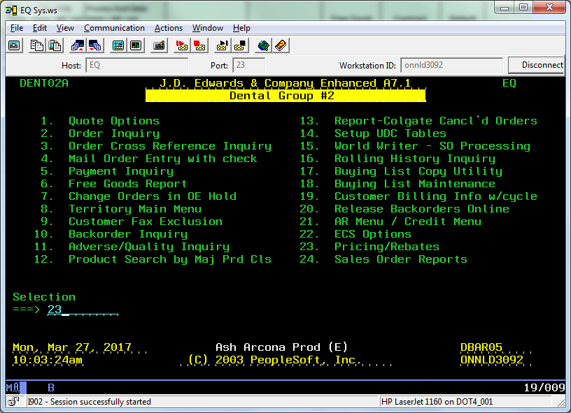

Setup Promo

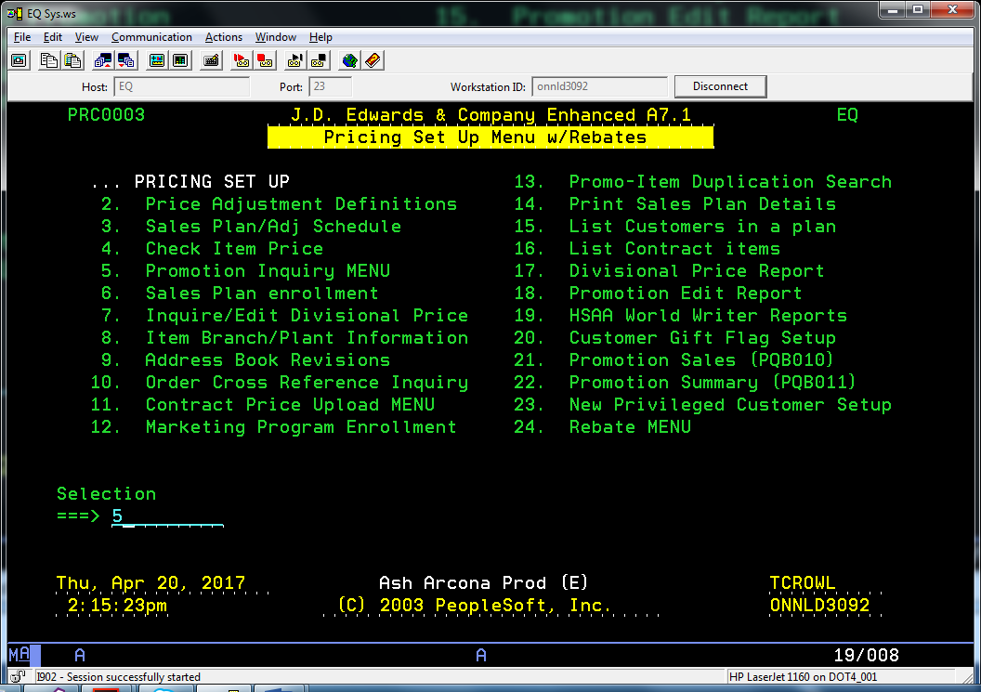

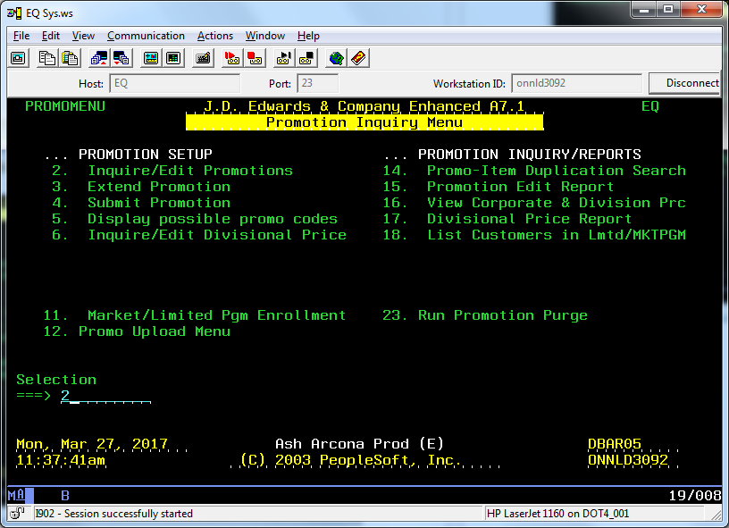

F6

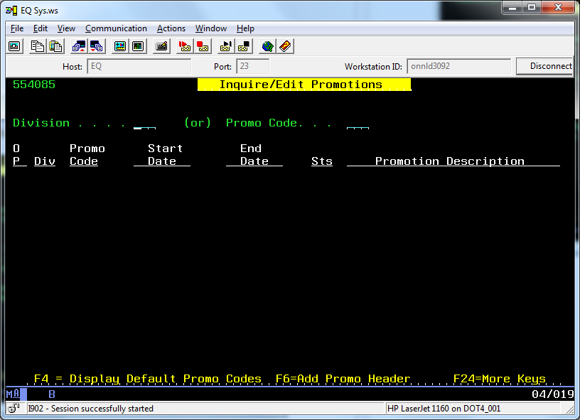

EZ Default for push to web; contract # missing?

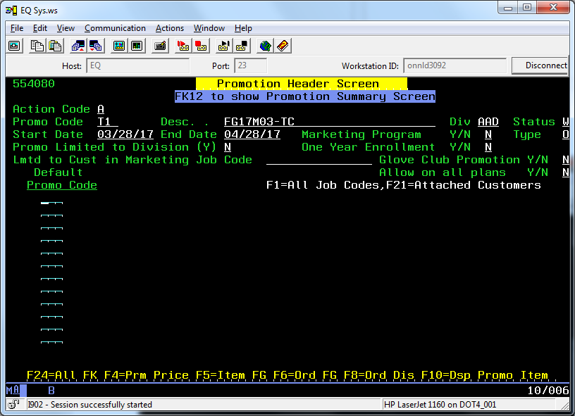

Push template to QA –

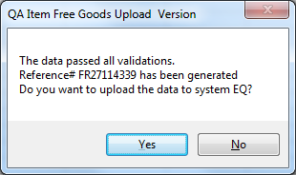

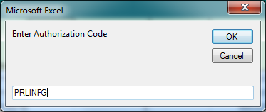

5 -> 2

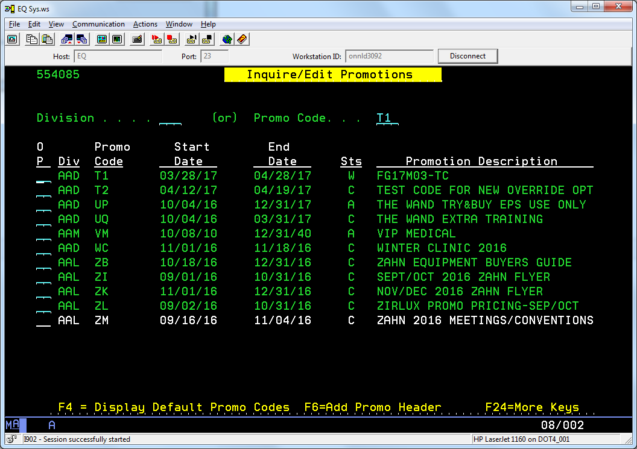

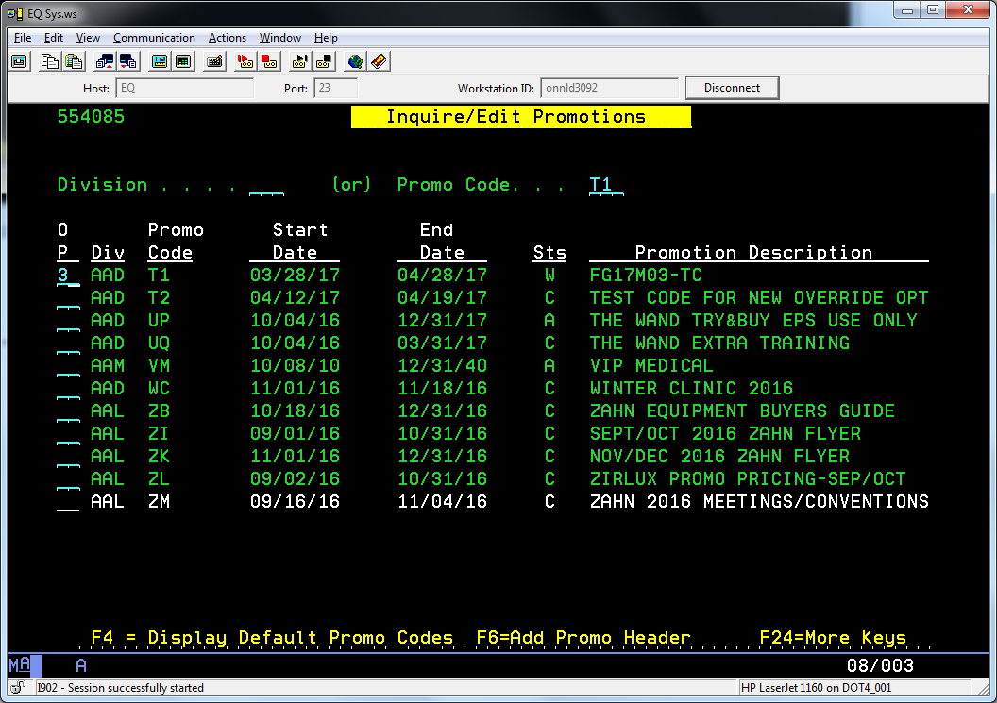

Review items from above (**s mean at the item level, not FS (blank otherwise)

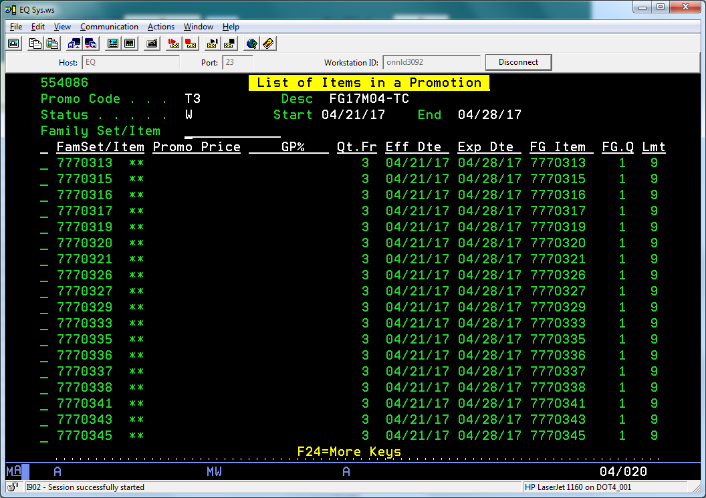

Submit promo

Promo status = Work, Submit, Active, Complete

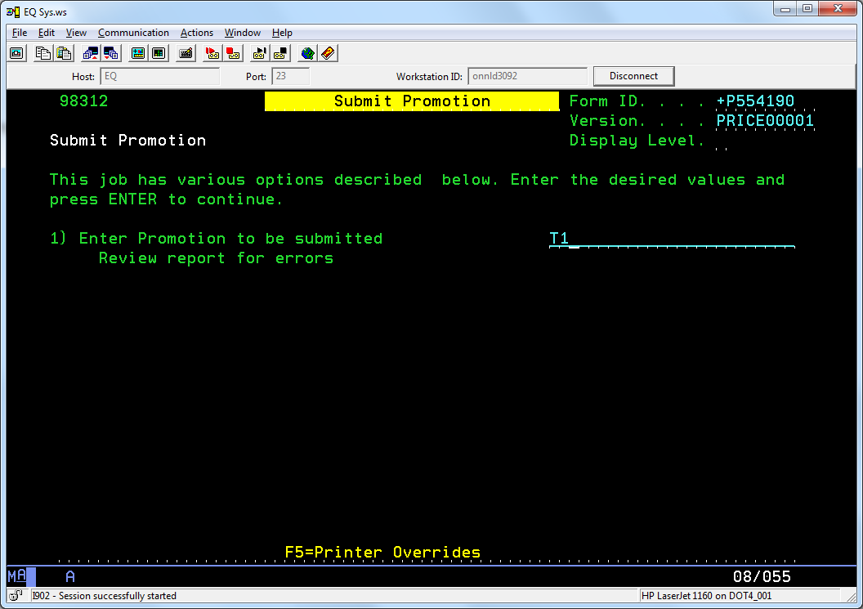

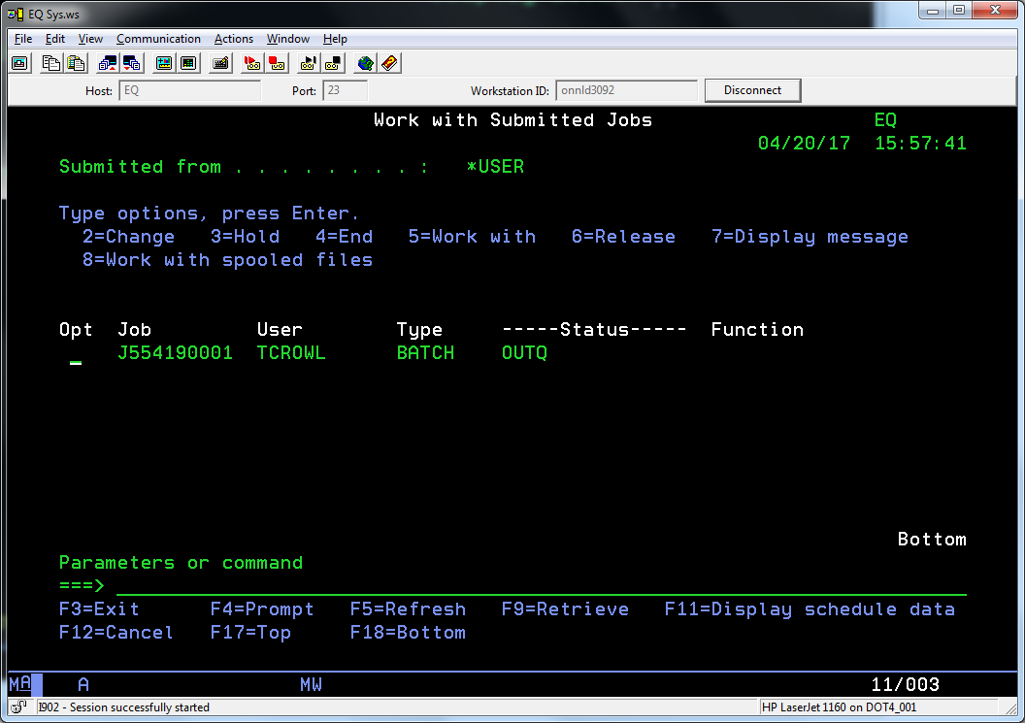

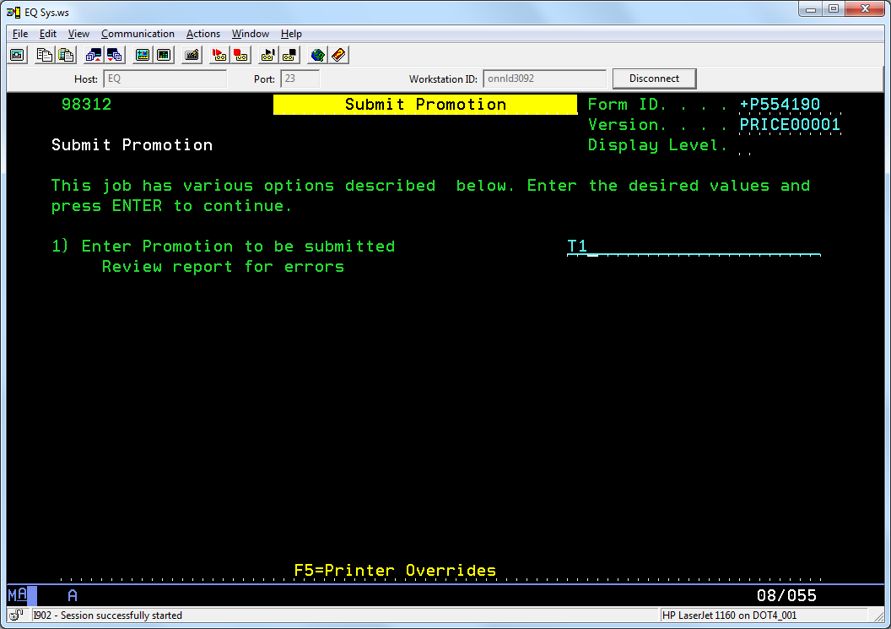

Note that promo date must be effective next day. Status = S for submit, then A when next day

Final – add new promo

F6

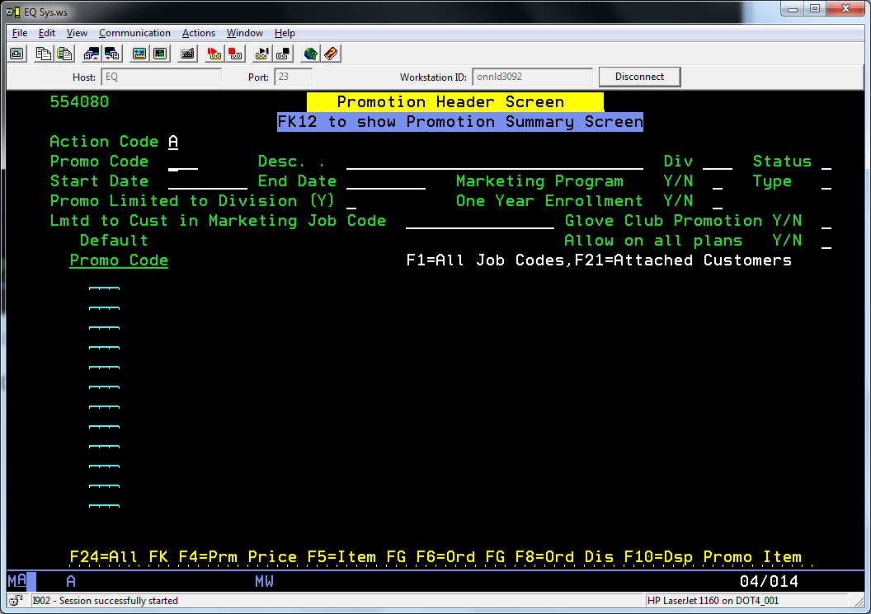

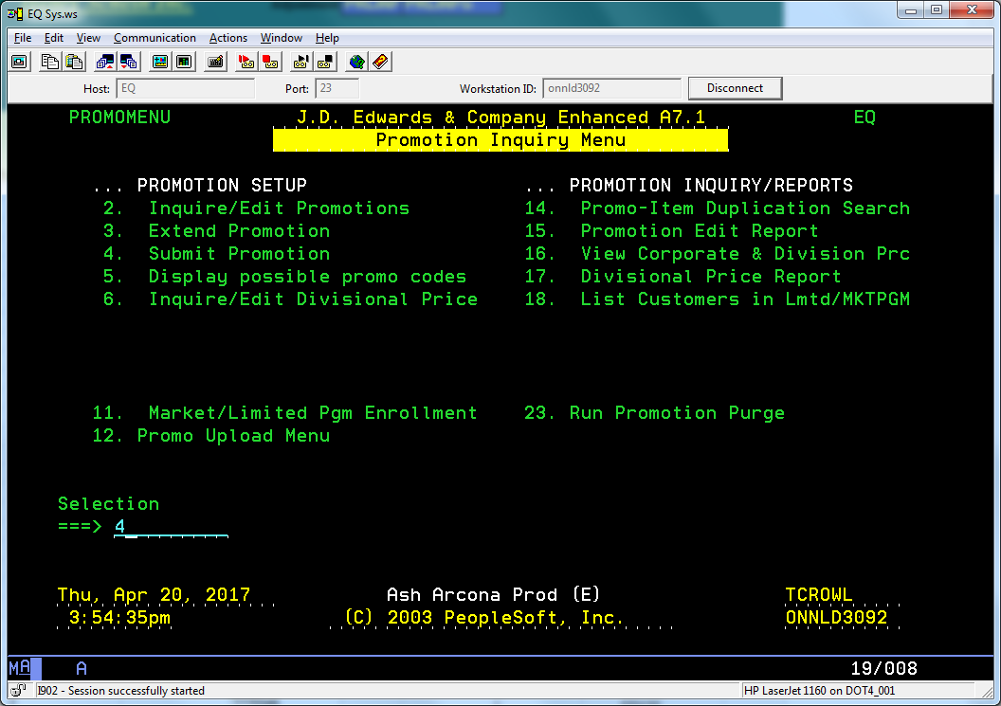

Not needed as per Deb (20 Apr 17) – Note that Proof mode in QA does not work

Review Proof in QA

